**Share an Attachment**

You can share attachments on your Google Calendar events.

**Instructions:**

1. Upload an attachment to your Google Calendar event from your Computer or Google Drive

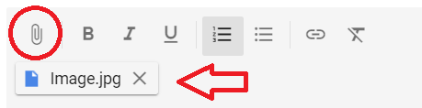

1. Click on the attachment to open it in a new window
2. Click “More actions” then “Share”



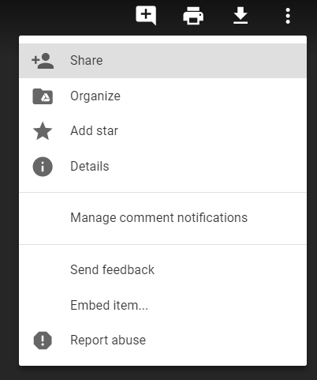

1. Click “Advanced”

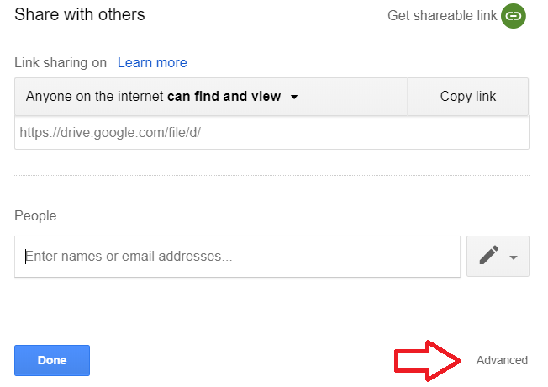

1. Click “Change…” under “Who has access”

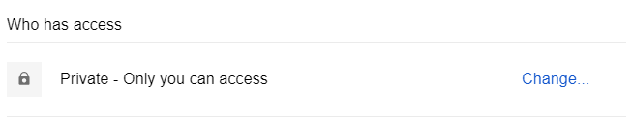

1. Select “Public on the web” and then “Save”

